STARTING DOTNET CORE

* -Open Source and Cross platform development
* -Latest version is ASP.NET Core 7.0 released on FEB-24-2023-
* -.NET was primarily released in 2000 as .NET 1.0
* -In 2016 MS came up with .NET Core 1.0 which allowed cross-platform development (that was not available in previous normal .NET framework).

**-FEATURES:**

1. Cross Platform and open Source

2. Fast Development

3. .NET Core now also works on other editors such as VScode etc

4. Based on MVC architecture.

**-WHAT IS ASP.NET CORE..?**

1- New version of ASP.NET

2- Open-Source FW for cross platform development

3- It's rewritten from scratch, initially launched as ASP.NET-5 and then renamed to ASP.NET-CORE-1.0

4- It's cross platform, high-performance

5- It has modular components (i.e everything is separated into modules) that gives flexibility.

**-DIFFERENCE B/W .NET & .NET CORE FRAMEWORK-**

1- .NET FW is old |.NET Core is new

2- Not open source | Open Source

3- Only For Windows | Cross Platform

4- Needs framework to be installed on windows | doesn't requires intallation

5- .NET dosen't support dependency injection | Allowed dependency injection.

6- Used to build WinForms,WPF for developing desktop and webapps

| Dosen't support desktop application development but focuses on web,windows mobile with ASP.NET and windows universal apps

7- Has single packaged installation and runtime enviroment for windows

|Needs to be installed independently

8- No support for Microservices | Supports Microservices

9- Lower performance | High scalability and performance

10- Dosent support Mobile Development | supports Mobile Development (Compatible with Xamarin)

11- Too heavy for CLI | Lightweight CLI (there's always an option of IDE in both)

12- All libraries are pack and shipped together | Shipped as Nugget packages

---

**-DIFFERENCE B/W ASP.NET & ASP.NET CORE-**

- ASP.NET was the first version of web-adapted .NET FW

|ASP.NET CORE is an improved version and continuation of ASP.NET

- ASP.NET CORE is opensource & crossplatform

- BOTH ARE BASED ON MVC ARCHITECTURE

- ASP.NET CORE has cloud and microservices support and it provides modularity(seperate files for evrything)

- ASP.NET was launched in 2002 based on .NET FW

- ASP.NET CORE is new standard version and it works on both .NET and .NET CORE FW

- ASP.NET CORE has no support for WebForms.

- ASP.NET CORE has no support for global.asx and web.config but appsetting.json is integrated.

- ASP.NET CORE requires VS-2015 or newer versions.

---

**-MVC IN ASP.NET CORE 6-**

-MVC is an architectural design pattern and not a programming language or framework.-

- Model : Business entities(table classes)

- View : UI and presentation logics.

- Controller : Business logics or bridge b/w Model and View.

**-MIDDLEWARE-**

- ASP.NET CORE introduced middleware,it's nothing but a component which is executed on every request in application

- It defines and control how application responds to HTTP requests

- Executed in program.cs file.

- Authentication and Authorization is also done here.

**- 2 TYPES of METHODS to run a middleware**

1- RUN() middleware defined using app.Run will never call next middleware and It only requires 1 paramerter (i.e Context). Server is started on app.run() method.

2- next() middleware Allows middleware to pass control to next item(middleware) in the pipeline and it needs 2 parameters (i.e Context and Next)

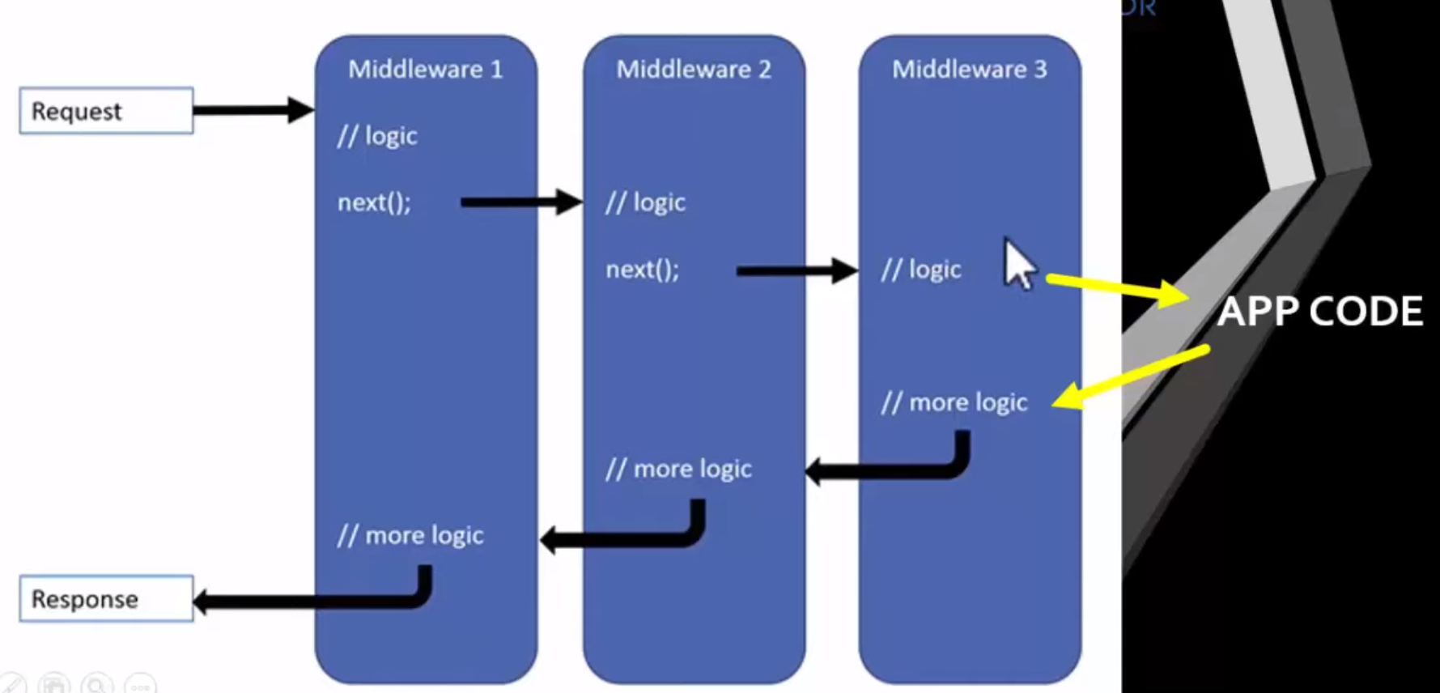

**-ROUTING-**

* Routing is a mechanism that checks the request from user and map that to Action method and controller in the Application.
* The Routing in ASP.NET Core MVC application is a mechanism in which it will inspect the incoming Requests (i.e. URLs) and then mapped that request to the controllers and their action methods.

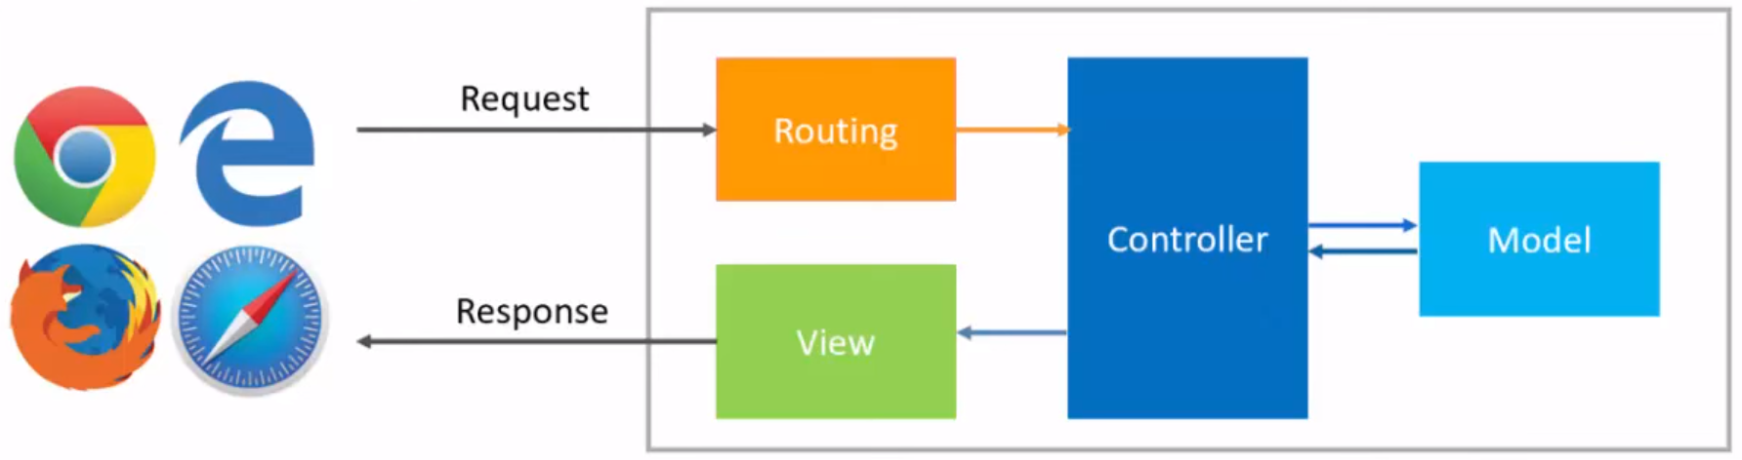

**-2 TYPES OF ROUTING-**

**-CONVENTION-BASED ROUTING**

In Conventional Based Routing, the route is determined based on the conventions defined

in the route templates which will map the incoming Requests (i.e. URLs) to controllers and their action methods.

{controller=Home}/{action=Index}/{id?}

**--ATTRIBUTE-BASED ROUTING**

we define routes for each action

method above it with attribute

like this

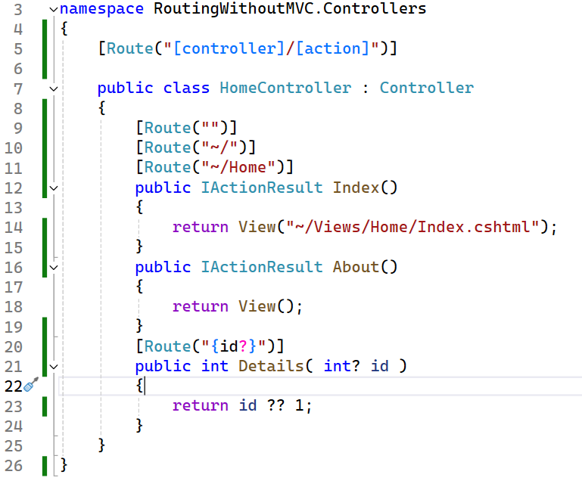---

**Map methods (Get, Put, Post, Delete)**

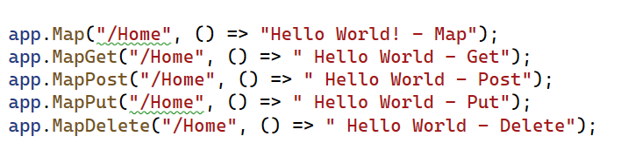

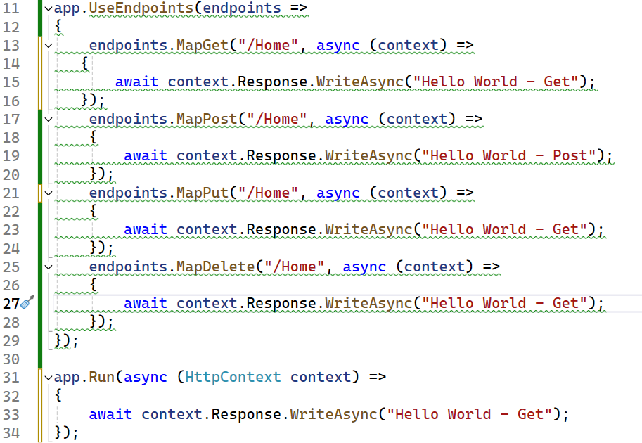

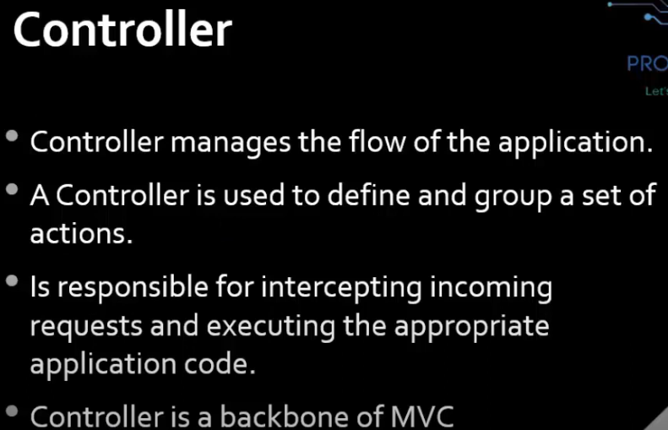

**EndPoint**

The MapGet method is used to define an endpoint. An endpoint is something that can be Selected, by matching the URL and HTTP method. Executed, by running the delegate.

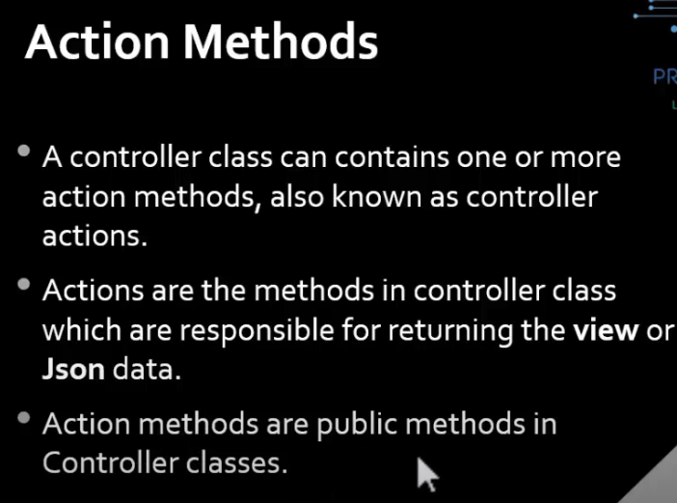

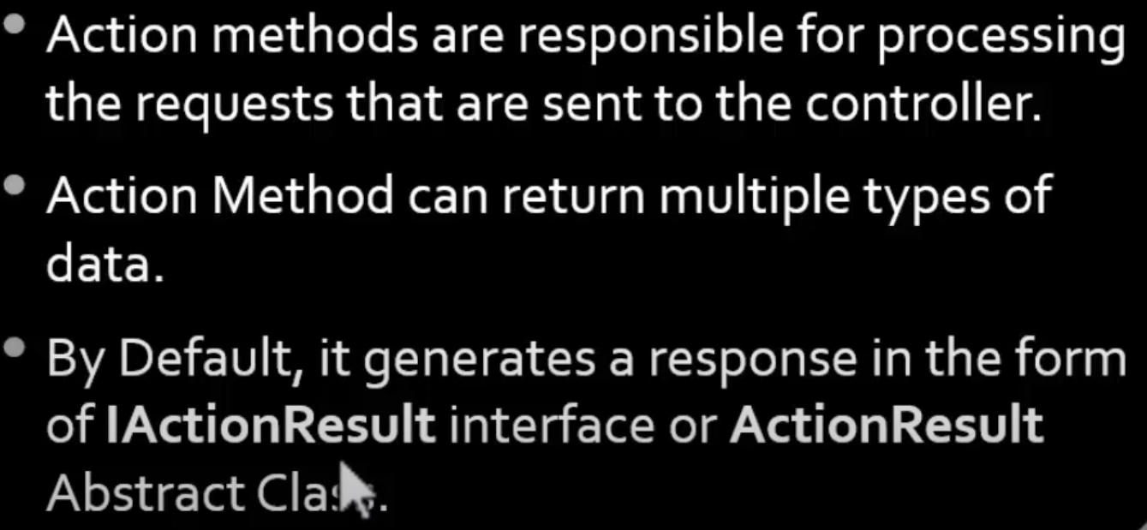

**\*Important Point*:** IActionResult is implemented by many classes like ViewResult, PartialViewResult, JsonResult etc

In that IActionResult is an interface and ActionResult is an abstract class that other action results inherit from.

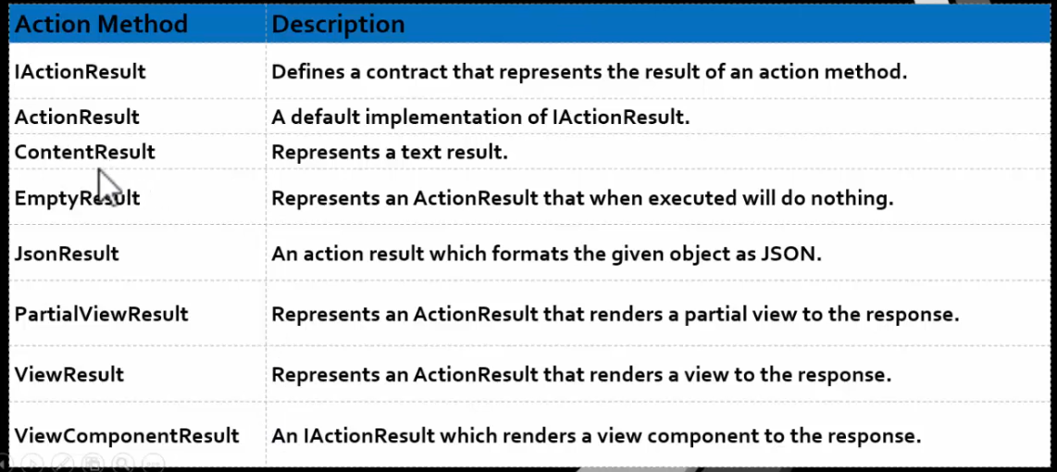

Watch video 13 for all action method implementations.

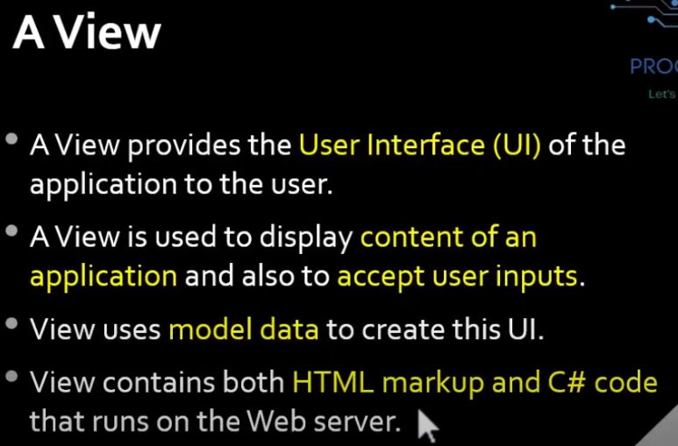

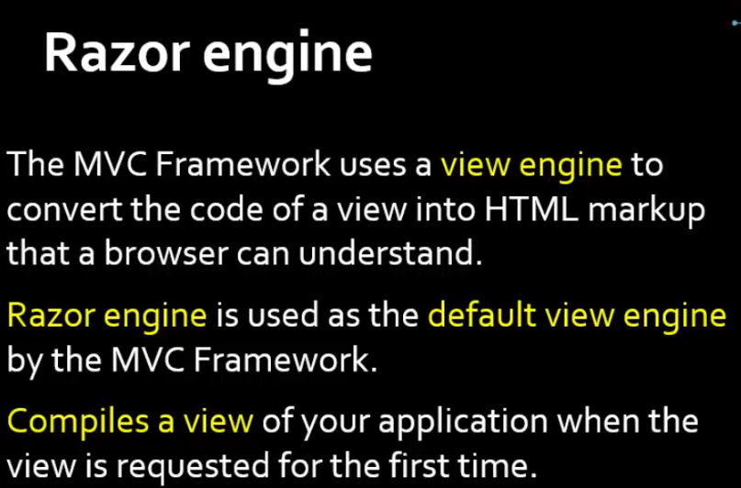

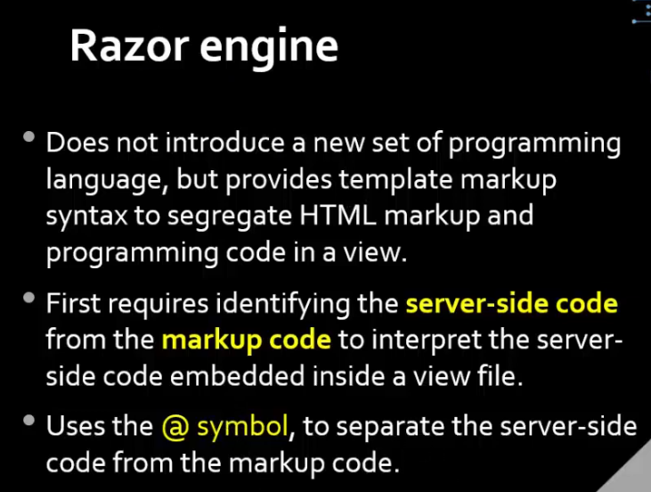

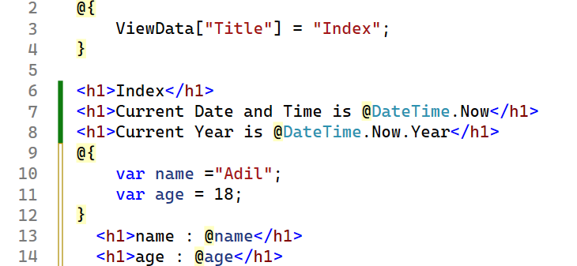

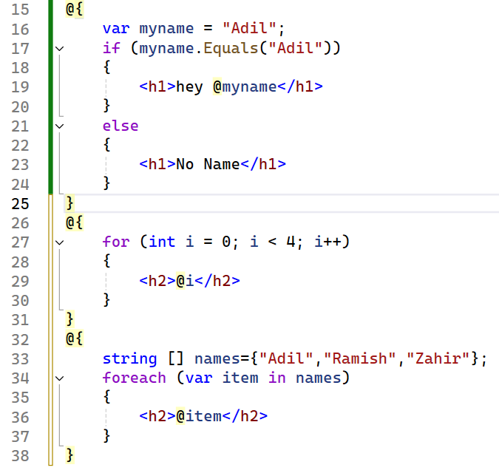

**Layout View**

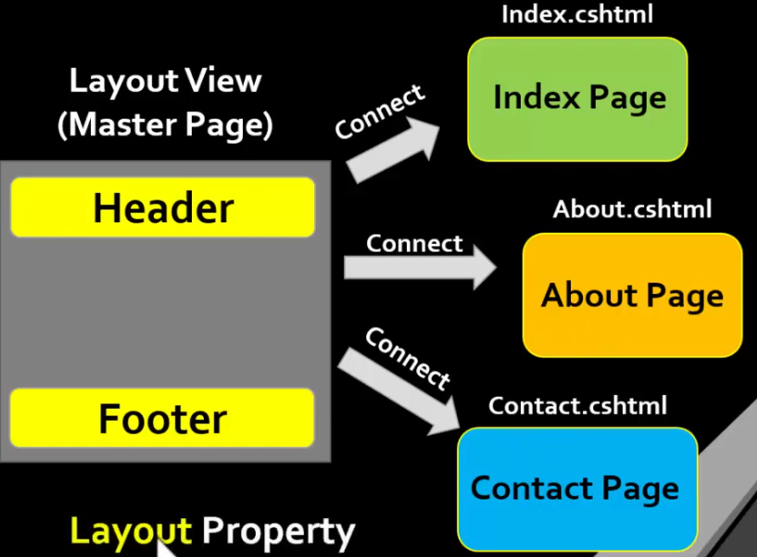



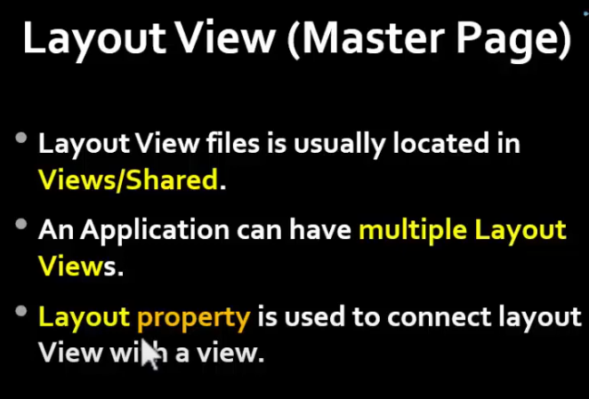

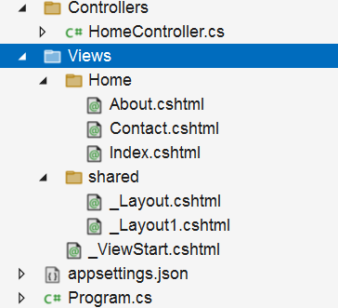

**View Start**

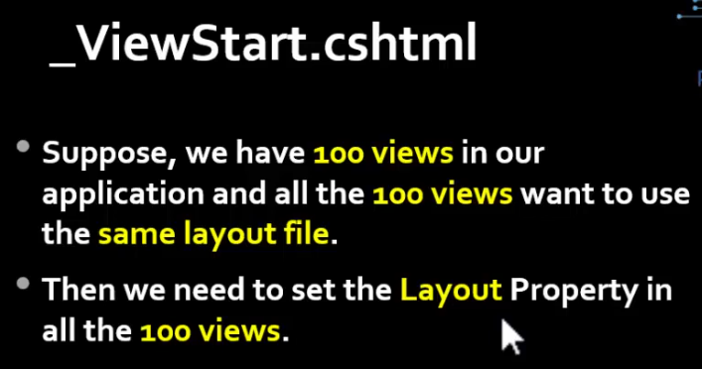

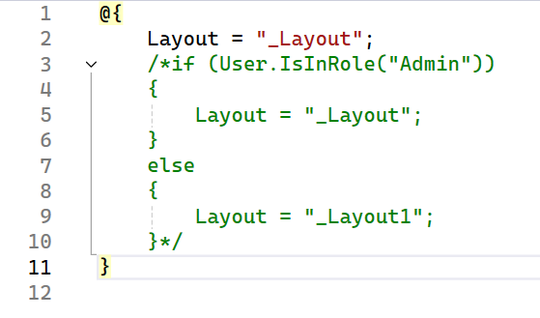

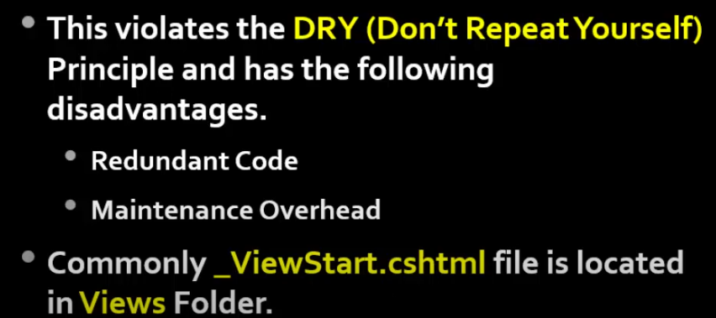

**Pass Data between view and controller**

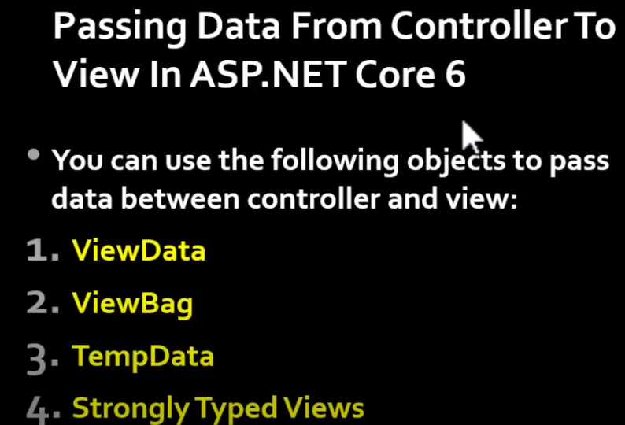

**ViewData**

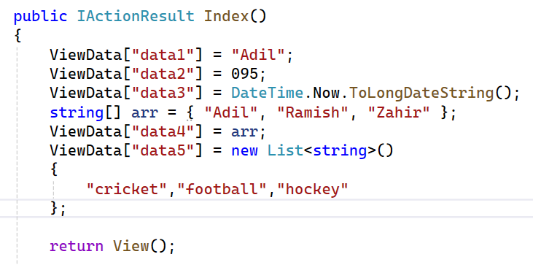

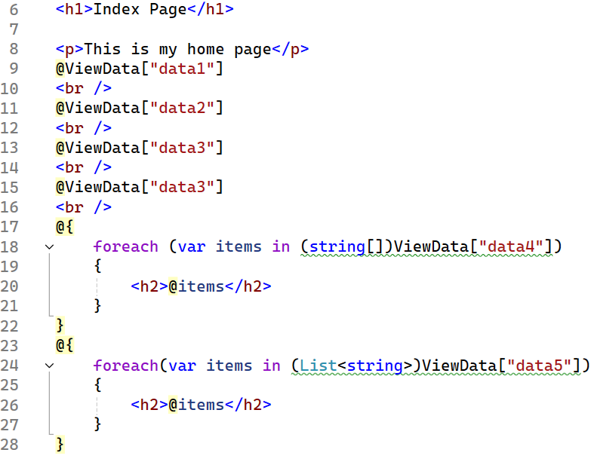

**ViewBag**

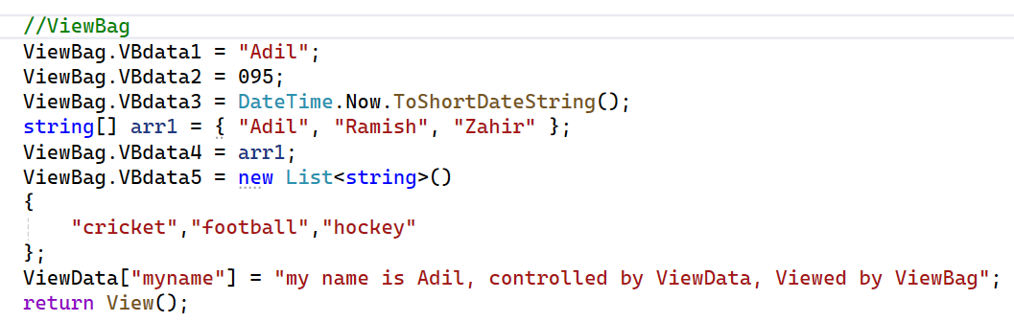

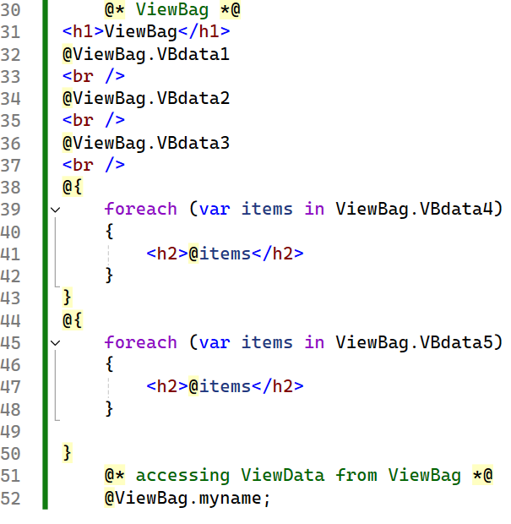

**TempData**

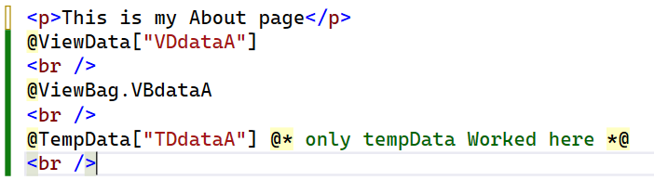

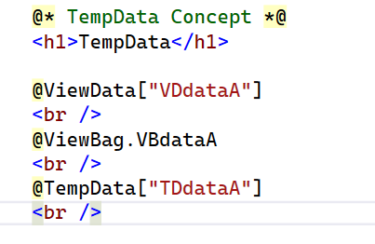

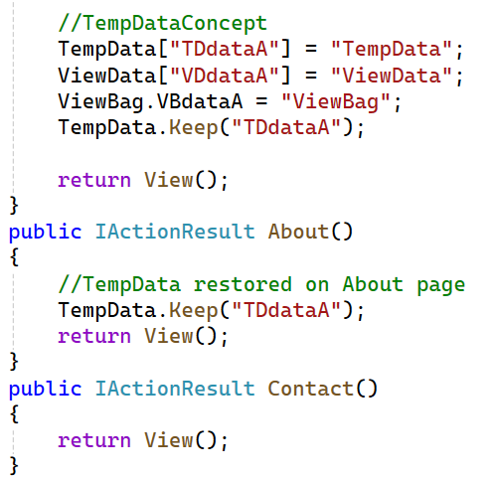

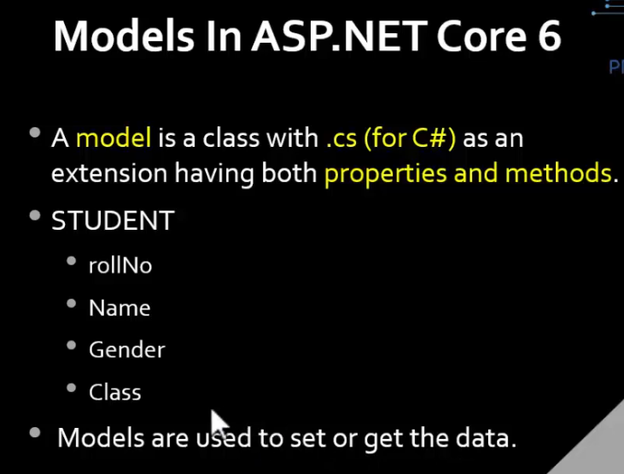

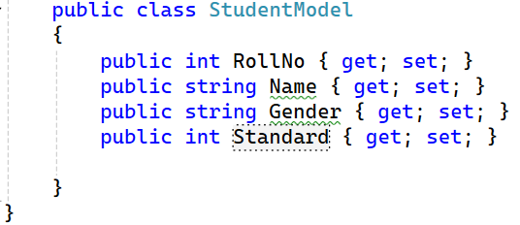

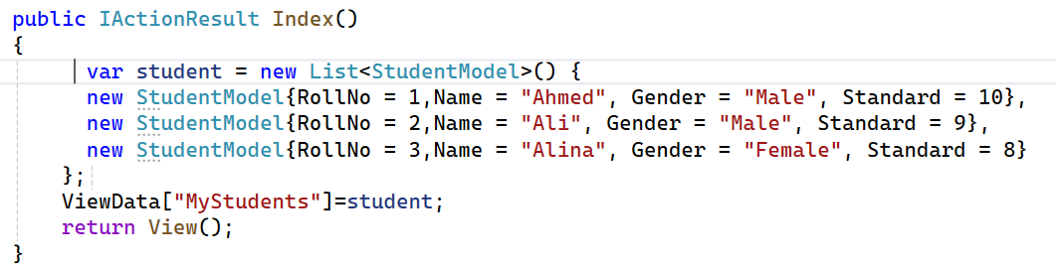

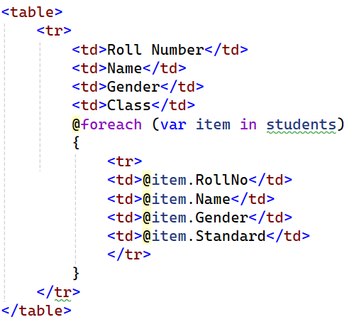

**Repository Pattern**

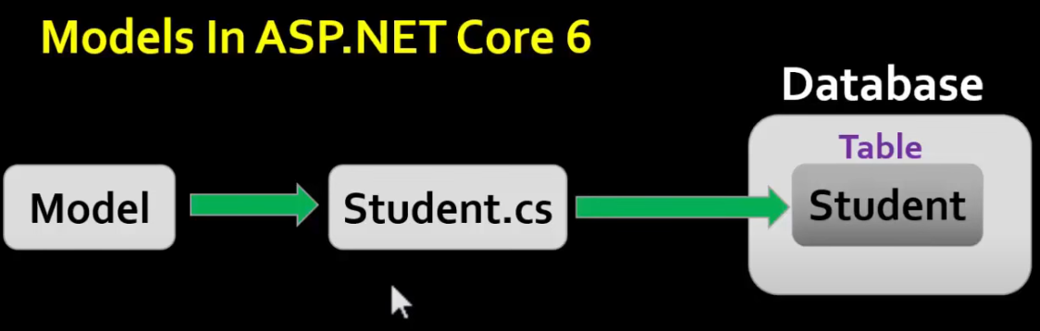

For every database table, there is a separate model class

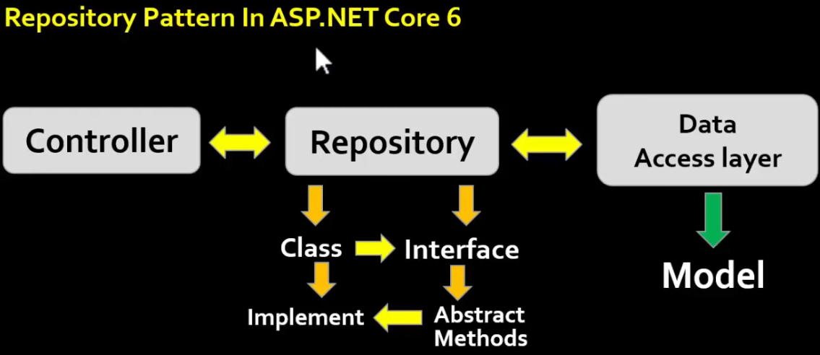

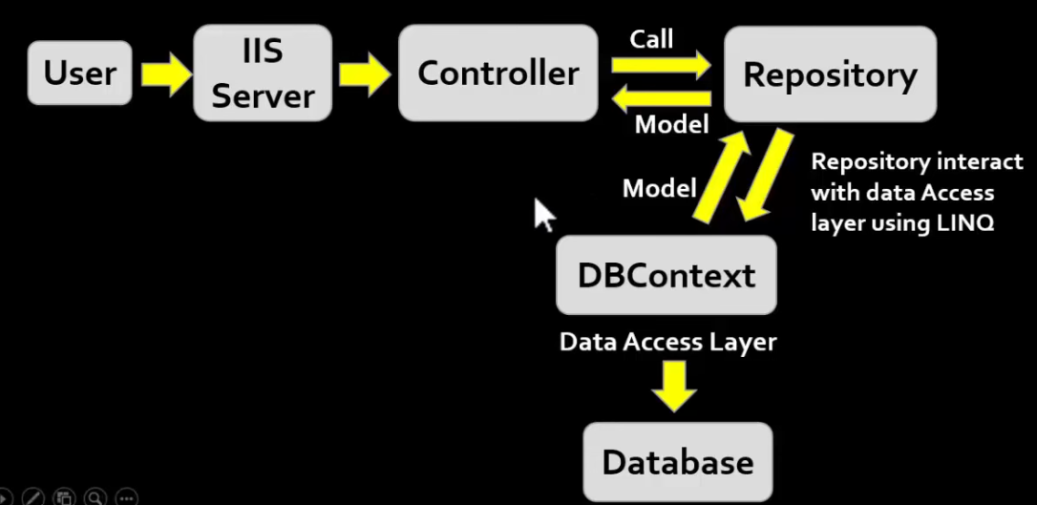

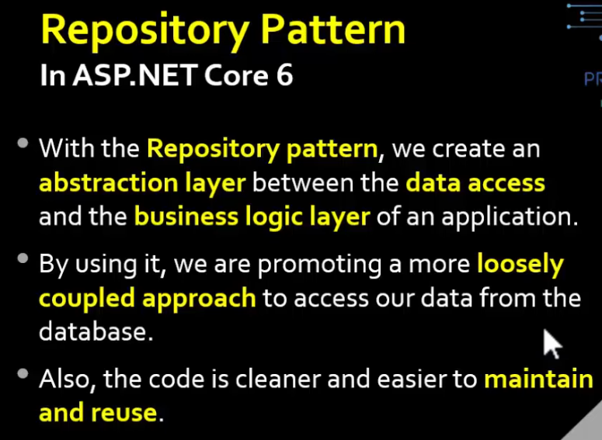

**Strongly Typed View**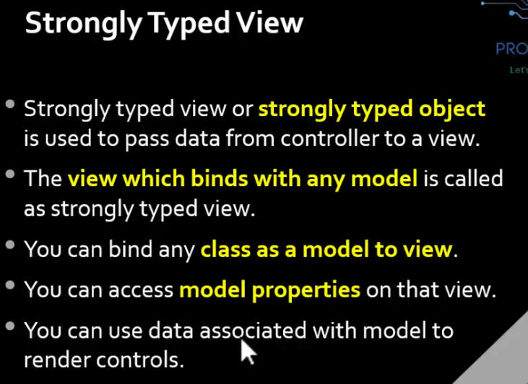

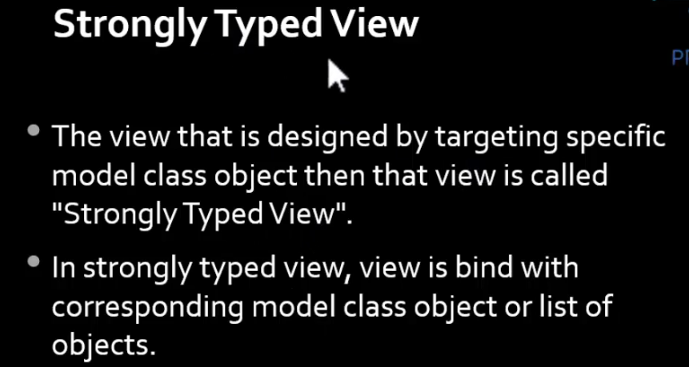

**-INSTALLING BOOTSTRAP/JQUERY** etc-

- All static files like BS,css,js,jquery are placed inside WWWROOT folder

- Images are also placed here

- click on WWWroot and click on add client side library and type twitter-bootstrap and install.k

- app.UseStaticFiles(): without usiing this method we cannot access any of our static files

- Libman.json file contains all the configuration for clients side libraries

---

--ENITTY FRAMEWORK CORE IN ASP.NET CORE--

- ORM Object Relational Mapping FW

- Redesigned version of EF 6 from scratch

-

--- WRITE THIS COMMAND TO GENERATE CONNECTION ---

install these Nuget packages first

1- Microsoft.EntityFrameworkCore.SqlServer

2- Microsoft.EntityFrameworkCore.Tools

3- Microsoft.EntityFrameworkCore.Design

{

Scaffold-DbContext "server=servername;database'MyDb;trusted_connection=true"Microsoft.EntityFrameworkCore.SqlServer -OutputDir Models

}

---

Scaffold-DbContext "server=PC1-3\SQLEXPRESS; database=hexashop; trusted_connection=true"Microsoft.EntityFrameworkCore.SqlServer -OutputDir Models

---

---IF ITS GIVING AN SSL CERTIFICATE WARNING USE THIS STRING ---

Scaffold-DbContext "Server=PC1-3\SQLEXPRESS;Database=hexashop;Trusted_Connection=True;TrustServerCertificate=True;" Microsoft.EntityFrameworkCore.SqlServer -OutputDir Models

----UPDATE----

(add -force flag at the end of string)

Scaffold-DbContext "server=PC1-3\SQLEXPRESS; database=hexashop; trusted_connection=true"Microsoft.EntityFrameworkCore.SqlServer -OutputDir Models -force

--shift the connection string from context file to appsettings.json--

"ConnectionStrings": {

"dbcs": "PASTE HERE"

},

--register Connection string in program.cs--

add these in program.cs after builder.Services.AddControllersWithViews();

--

var provider = builder.Services.BuildServiceProvider();

var config = provider.GetService<IConfiguration>();

builder.Services.AddDbContext<ArtevolContext>(item => item.UseSqlServer(config.GetConnectionString("dbcs")));

--

**ViewImports**

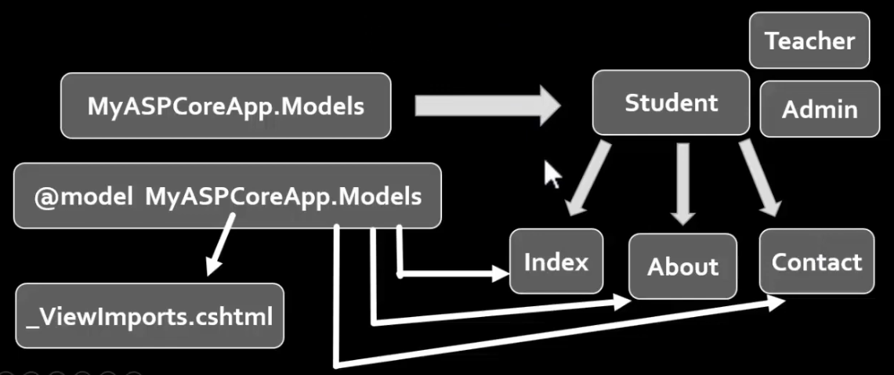

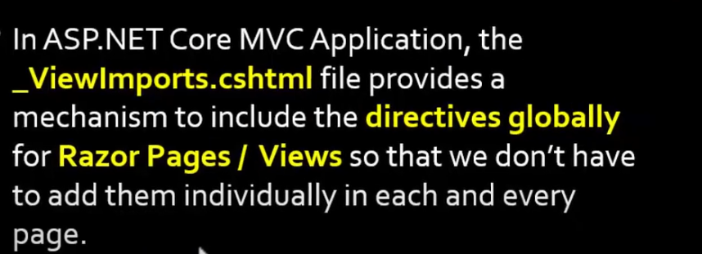

**Tag Helpers**

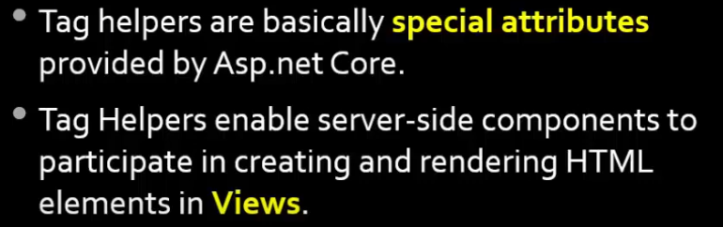

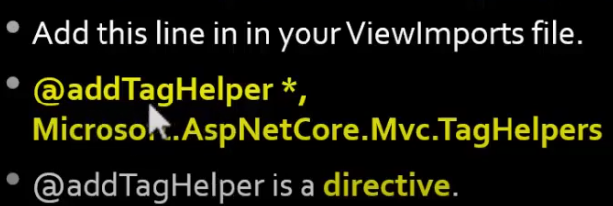

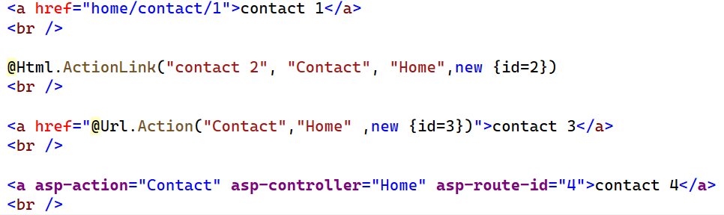

**asp-for Tag**

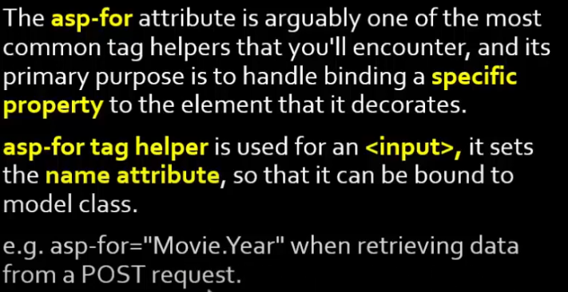

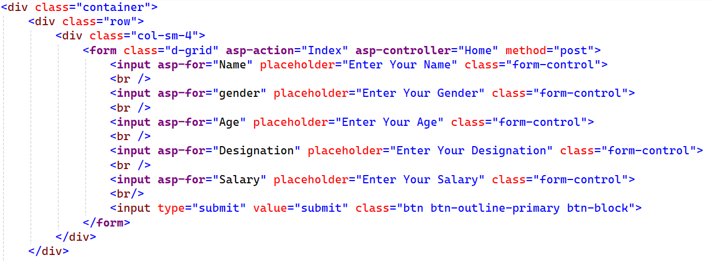

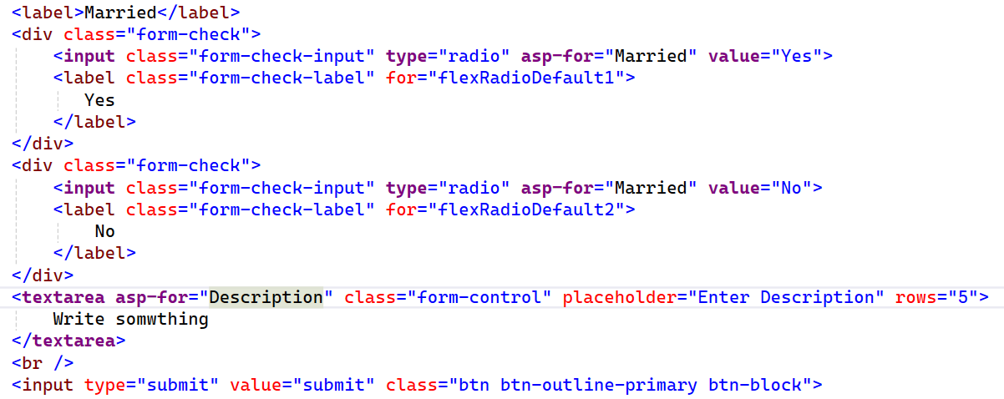

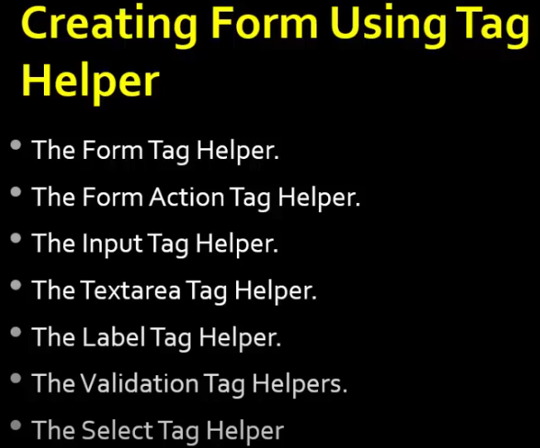

**Model binding / Mapping**

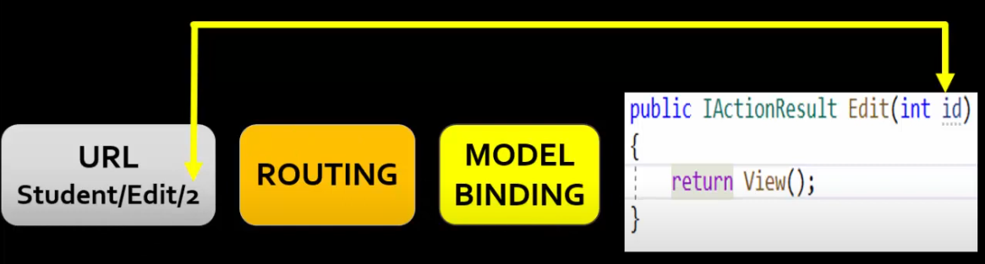

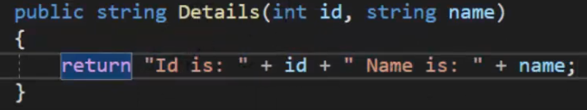

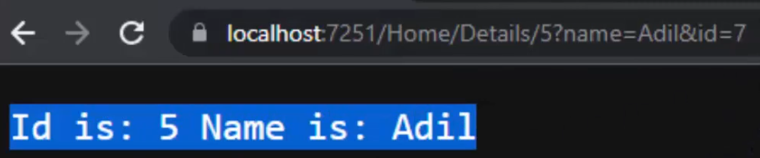

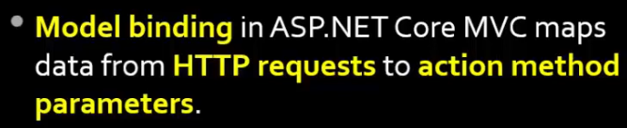

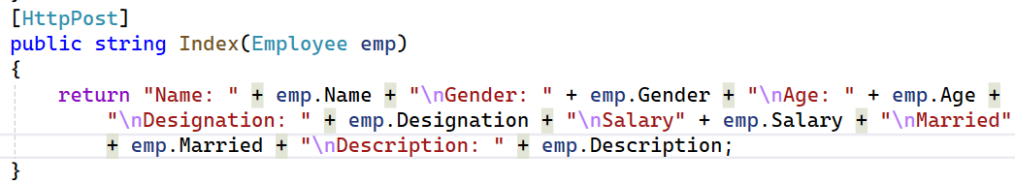

**Validation tag helpers**

Model

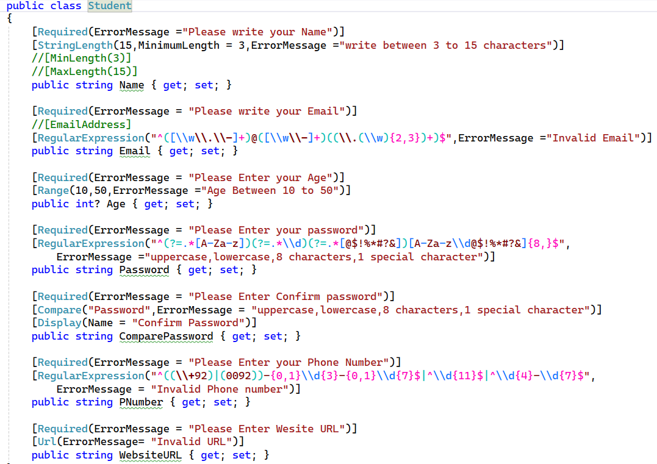

View

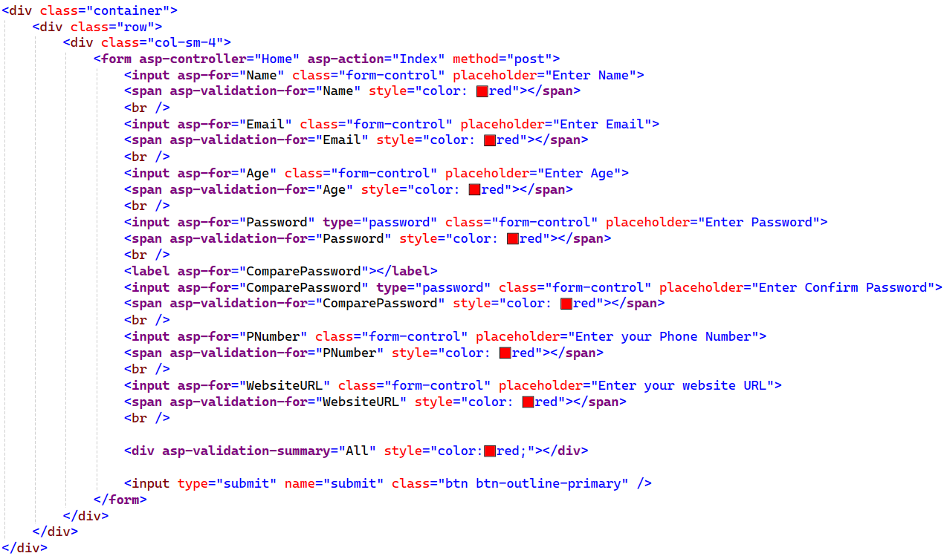

Controller

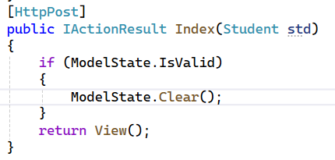

Output

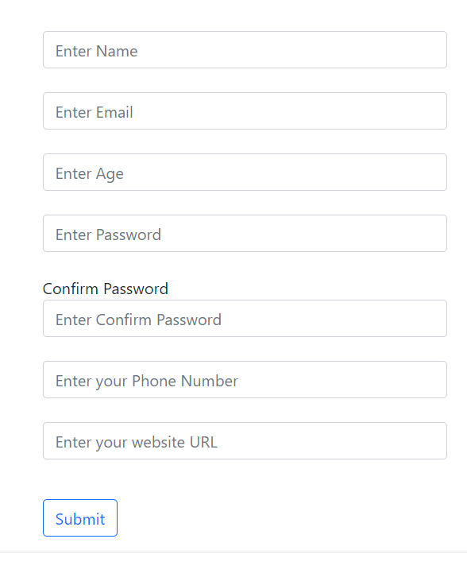

**ORM - (OBJECT RELATIONAL MAPPING)**

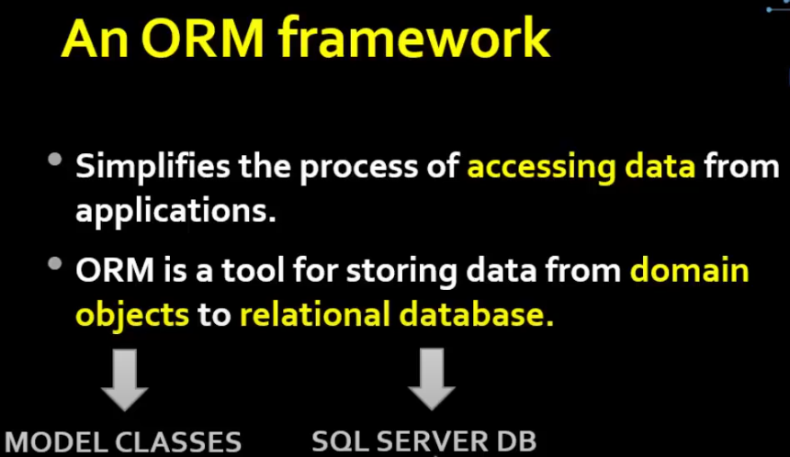

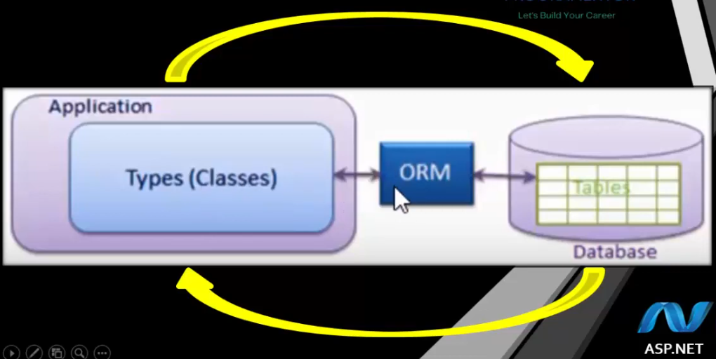

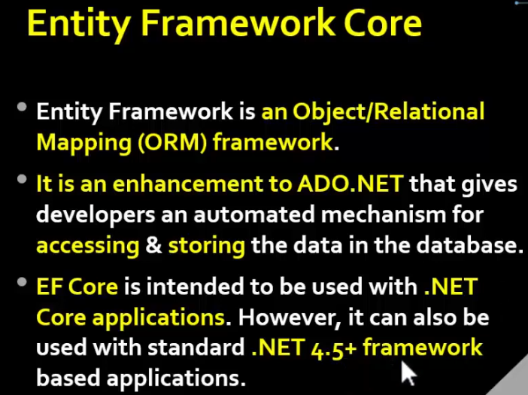

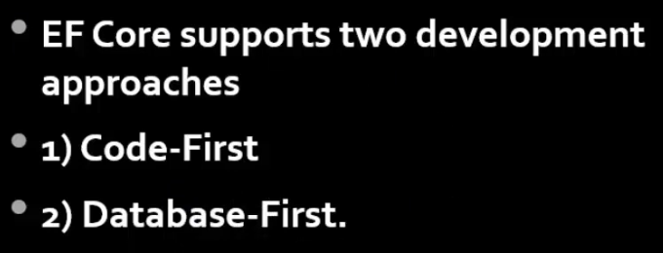

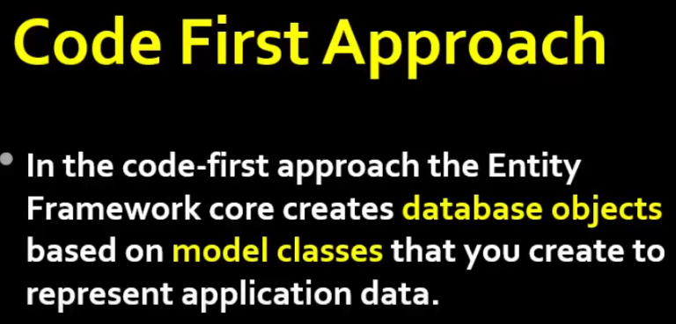

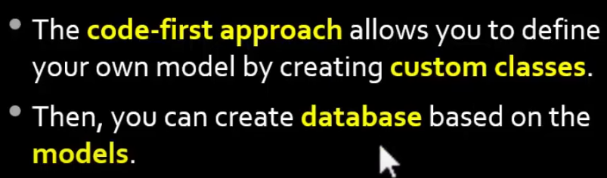

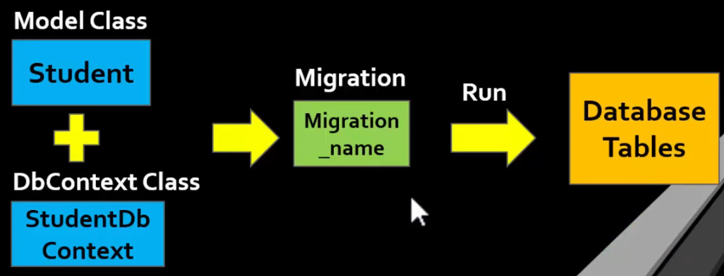

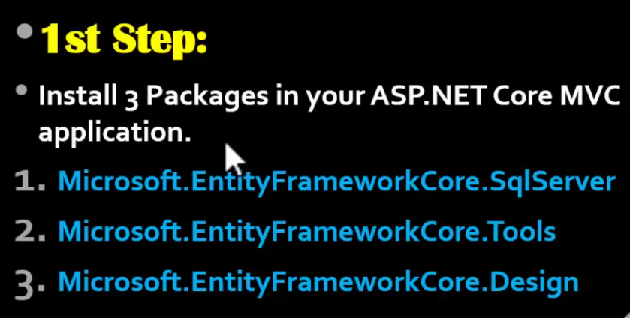

Dependencies > Manage NuGet Packages> brows > search for the packages

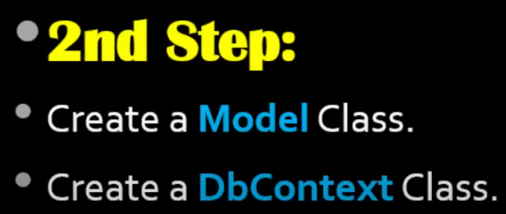

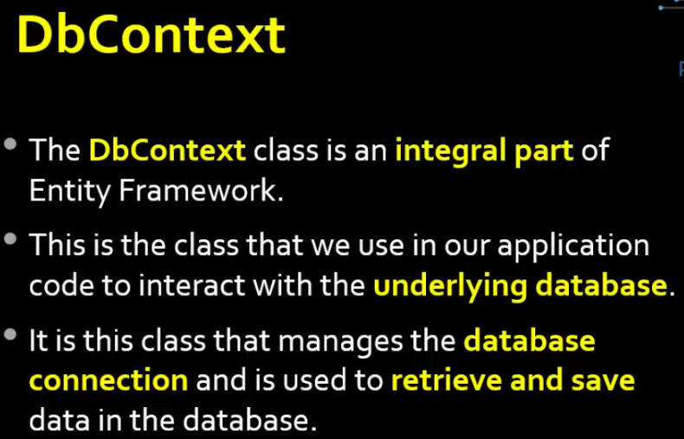

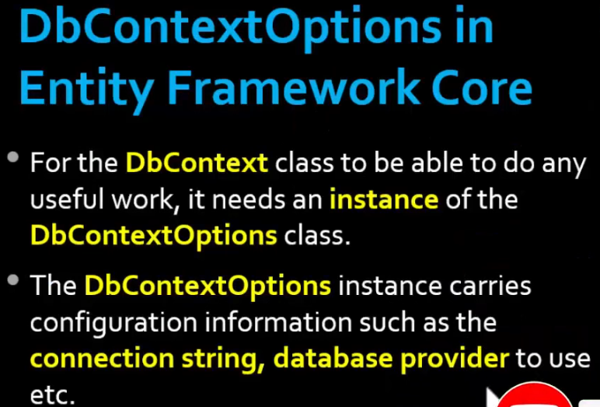

Base keyword call parent class constructor

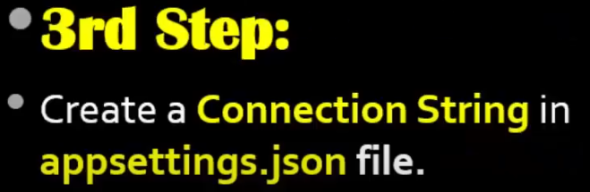









Tools > NuGet Package Manager > Package Manager Console

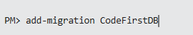 adding migration

updating/ executing database

After this command, the table will be created in database



**To add another column into the database**

Add another property into student model then execute these command





Now manually add some data in the table and write this code for controller

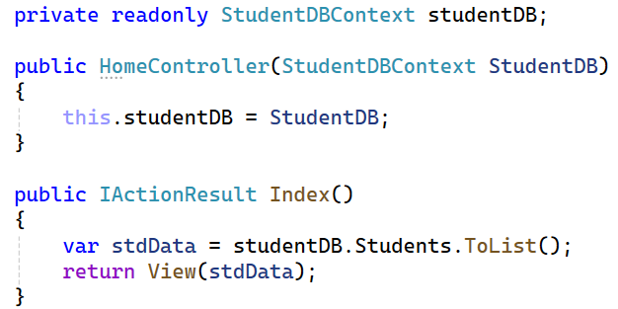

Create a new view file Index.cshtml

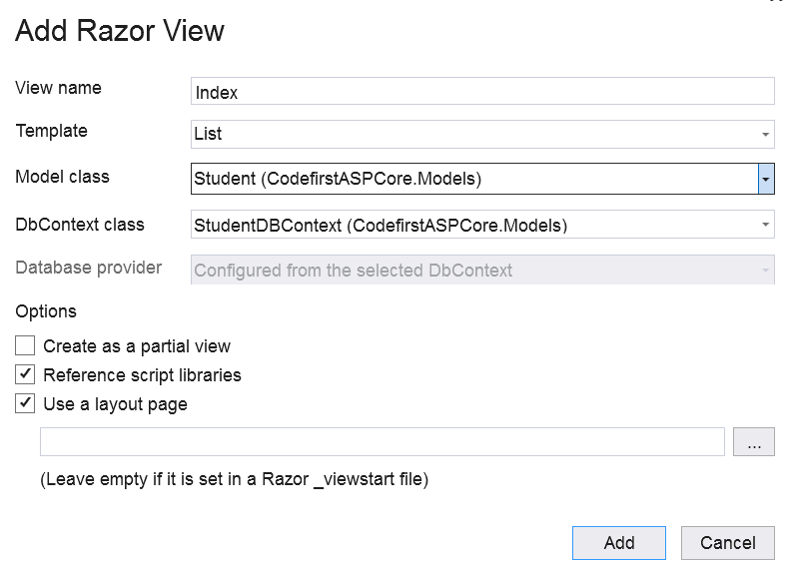

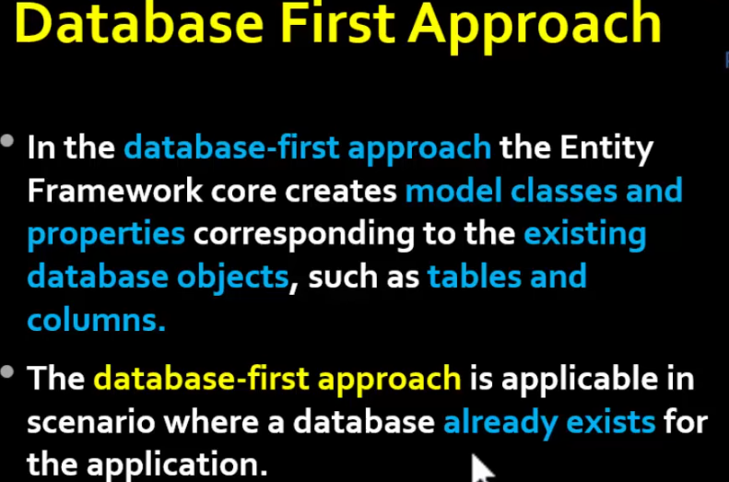

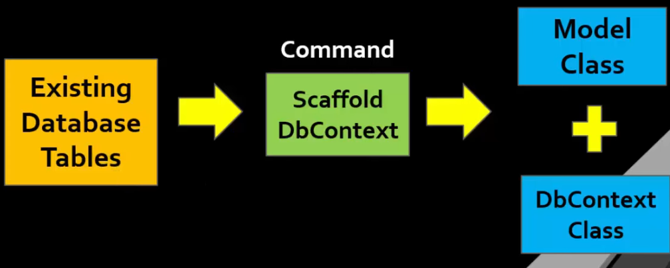



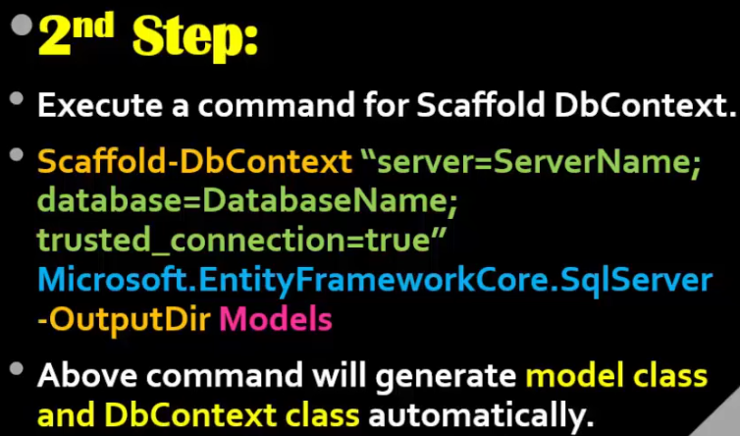

Scaffold-DbContext "server= DESKTOP-OJOVTMJ\SQLEXPRESS01; database= CodeFirstDB; trusted_connection=true; TrustServerCertificate=True " Microsoft.EntityFrameworkCore.SqlServer -OutputDir Models

**To call updated data from database**

Scaffold-DbContext "server= DESKTOP-OJOVTMJ\SQLEXPRESS01; database= CodeFirstDB; trusted_connection=true; TrustServerCertificate=True " Microsoft.EntityFrameworkCore.SqlServer -OutputDir Models -force

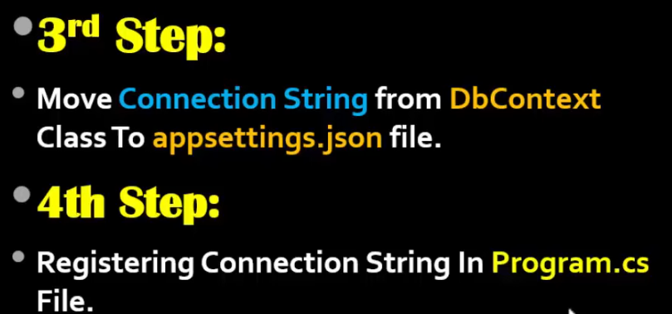

**Code for aapsettings.json file**

"ConnectionStrings": {

"dbcs": "server= DESKTOP-OJOVTMJ\\SQLEXPRESS01; database= CodeFirstDB; trusted_connection=true; TrustServerCertificate=True"

},

**Code for program.cs file**

var provider = builder.Services.BuildServiceProvider();

var config = provider.GetRequiredService<IConfiguration>();

builder.Services.AddDbContext<CodeFirstDbContext>(Items => Items.UseSqlServer(config.GetConnectionString("dbcs")));

var app = builder.Build();